S2

Celebration Cakes

Recipe Book

Pineapple Upside Down Cake

Ingredients:

50g self-raising flour
50g soft margarine
50g caster sugar
1 egg
1 x 15ml spoon warm water
½ glace cherry for base of tin
2 pineapple rings

25g margarine
25g brown sugar

Method:

- Set oven to 200º C or gas 6. Line and grease 1 x 15cm sandwich cake tin.
- Collect ingredients.
- Arrange the cherry and pineapple rings on the bottom of the cake tin, cream together the brown sugar and 25g margarine and spread onto the bottom of the cake tin.
- Mix all the ingredients for the sponge in a bowl until light and fluffy.
- Spread sponge mixture carefully over fruit.
- Bake till risen, golden brown and springy to the touch. Approx 15-20 min.
- Turn cake onto cooling tray.
- Serve.

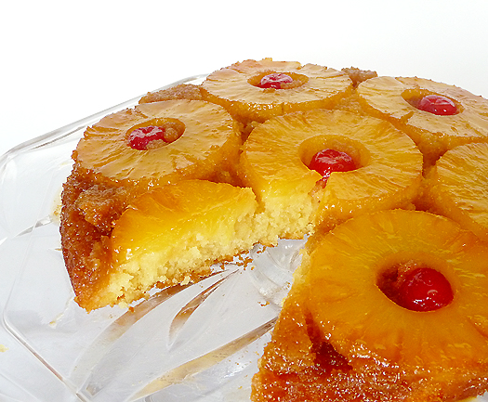

Chocolate Sponge Cakes
Ingredients:
50g soft margarine
50g caster sugar
50g SR flour
1 egg
15ml cocoa powder
Icing sugar to dust

Method:
- Set oven to 180°C or Gas mark 5.
- Cream margarine and sugar in large bowl until light and fluffy.
- Beat egg in a small bowl, sieve flour and cocoa powder into another small bowl.
- Beat in the flour and eggs into the margarine and sugar mixture until smooth.
- Divide the mixture evenly between 6 paper cases.
- Bake in the oven until they spring back when touched and are golden brown.
- Dust with icing sugar to serve.

Orange and Cream Sponge

Ingredients
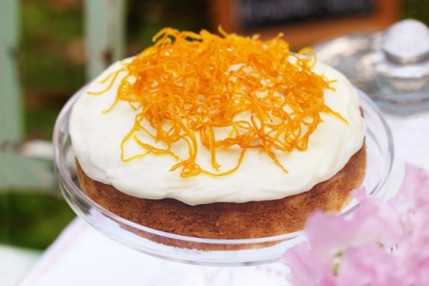
100g SR flour
100g caster sugar
100g soft margarine
2 eggs
50g mandarin oranges
75ml double cream

Method

- Set oven to 180ºC or gas mark 5. Grease and line a sandwich tin.
- Put the flour, sugar, margarine and eggs in a large bowl.
- Mix together, on lowest setting, with an electric hand mixer, until the mixture is soft dropping consistency.
- Spoon the mixture carefully into the sandwich tin and smooth over.
- Wipe any extra mixture from the side of the tin as this will burn in the oven.
- Bake until golden brown, well risen and springy to touch.
- Allow to cool for a few minutes and then turn onto a cooling rack.
- Whisk the cream to stiff peaks and dry the oranges.
- When the cake is completely cool, either pipe or spread the cream on top and decorate with the oranges.

Treacly Sticky Ginger Cake
(Between 2)
Ingredients:
225g plain flour 285ml milk
5ml mixed spice 1 egg
15ml ground ginger 85g black treacle
7.5ml baking powder 85g golden syrup
2.5ml bicarbonate of soda 115g caster sugar
75g margarine
Method:
- Set the oven to 180°C or gas mark 4 and grease and line a large loaf tin or 2 small ones with greaseproof paper.
- Sieve the flour and all the spices in to a large bowl.
- Measure the milk into a jug and beat in the egg.
- Melt the syrup, treacle, margarine and caster sugar gently in a small pot until the margarine has completely melted.
- Pour the melted mixture and the egg and milk into the large bowl and beat well until smooth.
- Pour the mixture into the loaf tin and bake until a skewer comes out clean and the cake is well risen and firm to touch.
- Turn out and allow to cool on a wire rack.
