Cheese and Ham Quiche

Ingredients

Pastry:
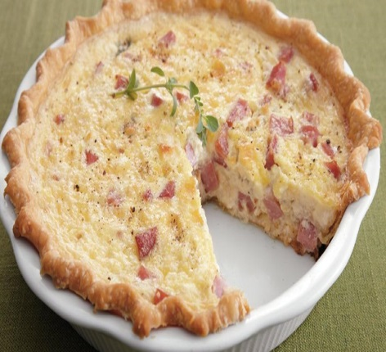
Plain flour 100 g
Margarine 50 g
Water to mix

Filling:
Onion ½
Ham 2 slices — finely chopped
Oil 5 ml
Eggs 1
Milk 100 ml
Cheddar cheese 50 g — grated
Salt and pepper

Method

- Set oven to gas mark 6/200°C. Adjust fan ovens accordingly.
- Sieve flour. Rub in margarine and lard. Add enough water to make a stiff dough.
- Roll out and line a 15 cm flan ring. Bake till just cooked.
- Reduce oven temperature to gas mark 4/180°C. Adjust fan ovens accordingly.
- Fry the onion in oil for three minutes.
- Place the onion and chopped ham in the flan case.
- Beat the egg and milk together. Add half of the cheese and seasoning.
- Pour the egg mixture over onion and ham. Sprinkle on the rest of the cheese.
- Bake till golden brown and lightly set.

