Cock-a-Leekie Soup
Ingredients:
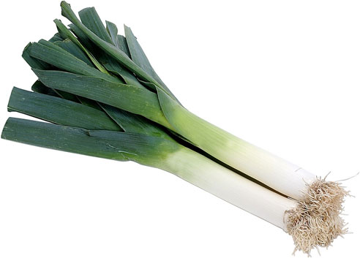
15ml oil
¼ chicken breast
½ leek
500ml chicken stock
25g long grain rice
2 de-stoned prunes (optional)

Method:
- Wash and finely slice the leek. Make up the chicken stock with ½ a stock cube and boiling water.
- Measure the rice into a sieve and rinse under cold water. Cut the prunes into 4 pieces.
- Cut the chicken into small 3cm pieces.
- Heat the oil in a medium pot and gently fry the chicken until white all the way through. Add the leeks and sauté on a medium heat without colouring them.
- Add the stock to the pot and bring to the boil.
- Add in the rice and simmer for 20 minutes, (if using the prunes add them 5 minutes from the end of cooking).
- Season to taste and serve with some chopped parsley to garnish.

