Flapjacks
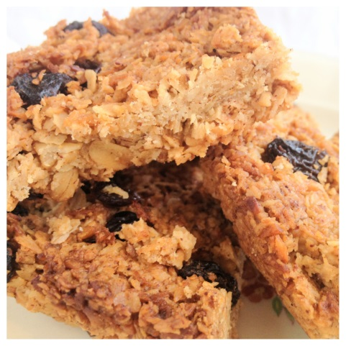
Ingredients:
50g porridge oats
25g soft brown sugar
25g butter
10ml golden syrup
Optional – 15ml spoon sultanas
Method:
- Set the oven to 190’C or Gas Mark 5.
- Collect the porridge oats and sultanas if using in a small bowl.
- Collect the soft brown sugar, butter and golden syrup in a small saucepan and slowly melt on a low heat until the butter melts and sugar dissolves.
- Add the porridge oats and sultanas if using into the pot and mix really well so everything is evenly coated.
- Press the mixture down into a foil container.
- Bake in the oven for approximately 15 minutes and leave to cool completely.
- Once cool cut your flapjacks into two slices.

