Forfar Bridies
Ingredients:
100g plain flour
50g margarine
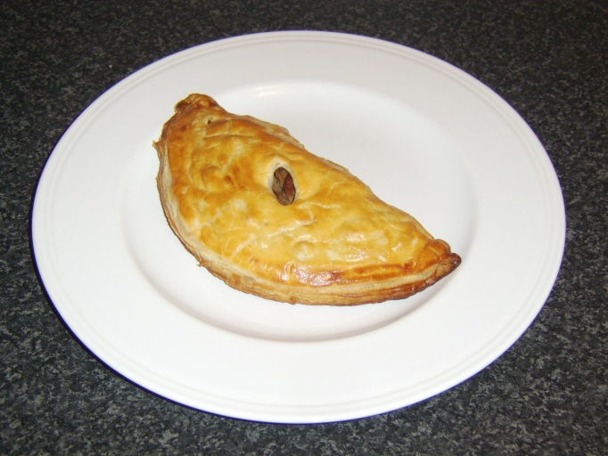
15ml cold water (approx’)
100g minced beef
½ onion
15ml beef stock
2.5ml Worcester sauce
½ egg

Method:
- Set the oven to gas 5/180ºC.
- Sieve the flour into a large bowl, add the margarine and rub-in until the mixture looks like fine breadcrumbs.
- Make a well in the centre and add enough water to bring it together with a knife to make a soft dough.
- Peel and finely chop the onion, measure the stock ad sauce into a small bowl.
- Beat the egg in another small bowl.
- In a frying pan, brown the mince and then add the onion and cook for 3-4 minutes. Pour in the stock mixture and stir through and remove from the heat to cool.
- Lightly flour the table and roll out the pastry into two 15cm rounds.
- Place the cooled mince mixture on one half of each of the pastry circles. Brush the edges with the beaten egg and fold over and seal with a crimped edge.
- Place the bridies onto a floured baking tray, brush the top with egg and bake for about 25 minutes until golden brown.

