Fruit cheesecake
Ingredients
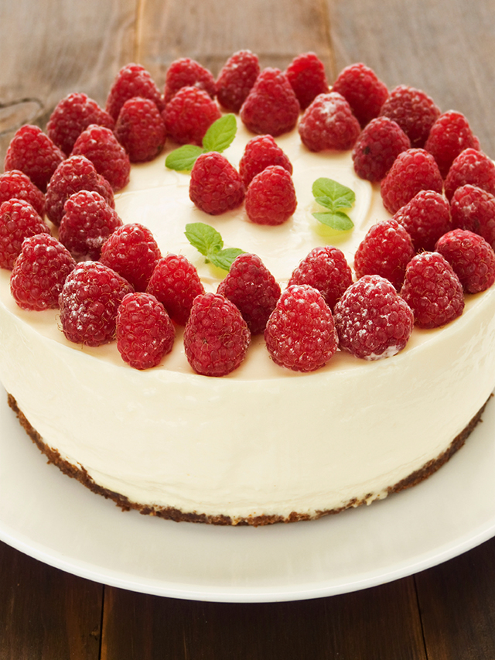
Base
50g margarine
100g crushed digestive biscuits
Filling
75g cream cheese
25g caster sugar
100ml raspberry yogurt
125ml double cream
Method
- Crush the biscuits and melt the margarine in a pan. Mix them together and press into a 15cm flan ring. Chill
- Place the cream cheese and sugar in a large bowl. Beat them together very lightly with a wooden spoon until just mixed.
- Gently mix in the yogurt.
- Whip up all of the cream in a separate bowl to form stiff peaks.
- Remove 2 tbsp of cream and place into a piping bag (for the decoration).
- Fold the rest of the cream into the cream cheese, yogurt and sugar mixture.
- Pour this mixture over the base and smooth with a palate knife. Chill to set.
- To serve – Remove flan ring.

