“Pot” Noodles
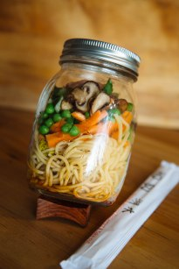
Ingredients:
½ sheet noodles
1 spring onion
15ml mixed frozen vegetables
1 slice cooked chicken
¼ vegetable stock cube
10ml soy sauce

Method:
- Half fill a large pot with water and bring to the boil
- Add the noodles and boil for 3-4 minutes then drain through a sieve
- Chop the spring onion and cooked chicken into small pieces
- Place the vegetable stock cube and soy sauce into the bottom of your “pot” then layer with the noodles and the vegetables
- When ready to eat pour boiling water over the layers (roughly 100ml but more or less depending on how watery you like your pot noodles) and stir well!

