S3 Home Economics
Cookie Challenge
Recipes

Oaty Sultana Cookies (between 2)
Ingredients:
125g soft margarine
25g caster sugar
50g soft brown sugar
75g SR flour
125g rolled oats
50g sultanas

Method:
- Set the oven to gas mark 4 or 180°C. Line a baking tray with greaseproof paper.
- Cream the margarine, caster sugar and soft brown sugar together until light and fluffy.
- Mix in the sultanas and then gradually sieve in the flour mixing well. Add the oats and bring together with your hand to form a soft ball.
- Divide the mixture into about 12 cookies, roll into a ball and then place on the baking tray. Flatten slightly with a fork.
- Bake for 15-20 minutes until the cookies are pale golden around the edges, but still soft in the middle.
- Cool slightly and then transfer to a cooling rack to firm up.

Smartie Cookies
Ingredients:
50g soft margarine
50g soft brown sugar
15ml syrup
75g SR flour
1 tube of Smarties

Method:
- Set the oven to 180°C or gas mark 4.
- Cream the margarine and sugar together until light and fluffy. Add the syrup and mix well.
- Gradually sieve in the flour and then add the Smarties. Bring together with your hand to form a soft ball.
- Divide into 8 even sized balls and then place on a lightly floured baking tray.
- Flatten gently with your fingers and then place in the oven.
- Bake for 12 minutes until pale golden at the edges. Place on a cooling rack to firm up.

Cheese Biscuits
Ingredients:
115g plain flour
55g grated strong cheese (cheddar is best)
55g unsalted butter
½ an egg
1.25ml salt
1.25ml freshly ground black pepper
1.25ml paprika (for those that like a little spice)

Method:
- Preheat oven to 180C or gas mark 4.
- Sieve the flour into a large bowl, rub-in the butter until it looks like fine crumbs. Stir in the cheese.
- Add salt and pepper to taste, add paprika for an additional kick!
- Gradually add the egg and mix with a knife until it forms a soft ball. You may need to add a little water to encourage the ball to form.
- Roll the mix on a lightly floured board to a thickness of 8mm and cut the biscuits.
- Place the biscuits on a floured baking tray and bake in the oven for 10 minutes, or until golden brown.
- Place onto a cooling rack to firm up.
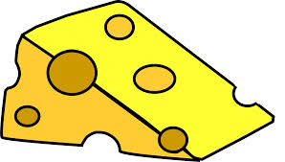

Anzac Biscuits (between 2)
These delicate biscuits were made to send to the ANZACS (Australian and New Zealand Army Corps) serving in Gallipoli.
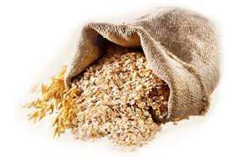
Ingredients:
85g rolled oats
85g coconut
100g plain flour
- 100g caster sugar

100g margarine
15ml syrup
5ml bicarbonate of soda plus 30ml boiling water

Method:
- Set the oven to 180°C or gas mark 4. Line a baking ray with greaseproof paper.
- Put the oats, coconut, flour and sugar into a large bowl, mix well.
- Melt the margarine and syrup in a small pan.
- Mix the bicarbonate of soda with the boiling water and add to the margarine and syrup mixture.
- Make a well in the middle of the flour mixture and pour in the margarine mixture.
- Stir gently to combine all of the ingredients.
- Spoon dessertspoonful’s of the mixture onto the baking tray, spacing them well apart.
- Bake for 10 minutes until golden and then cool on a cooling rack to firm up.

Mini Quiche
Ingredients:
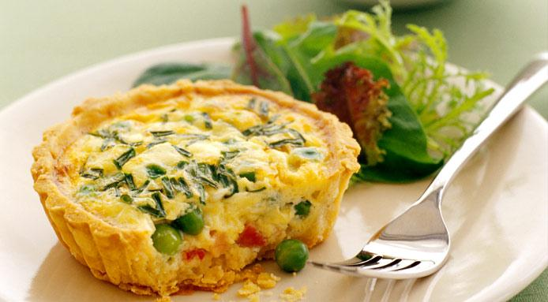
100g plain flour
50g margarine
15ml cold water
1 egg
50ml milk
50g grated cheese
1 slice of cooked ham (diced)
Seasoning

Method:
- Set the oven to 180°C or gas mark 6. Lightly flour a patty tin.
- Sieve the flour into a bowl, add the margarine and cut into 6-8 pieces.
- Rub the margarine into the flour until the mixture looks like breadcrumbs.
- Using a round-bladed knife make a well in the centre of the mixture, add the cold water and mix to a soft dough that is not sticky.
- Bring the mixture together and knead lightly until smooth.
- Roll out to about 0.5cm thick and cut out with a large cutter. Place in the patty tin.
- Crack the egg into a small bowl and whisk with a fork. Add the milk, cheese and diced ham to the egg, season and mix well.
- Pour the mixture into the pastry cases, bake until the egg is set and the quiche are golden brown.
- Transfer onto a cooling rack to cool.

