S1
Healthy Eating
Recipe Book
Perth Grammar School
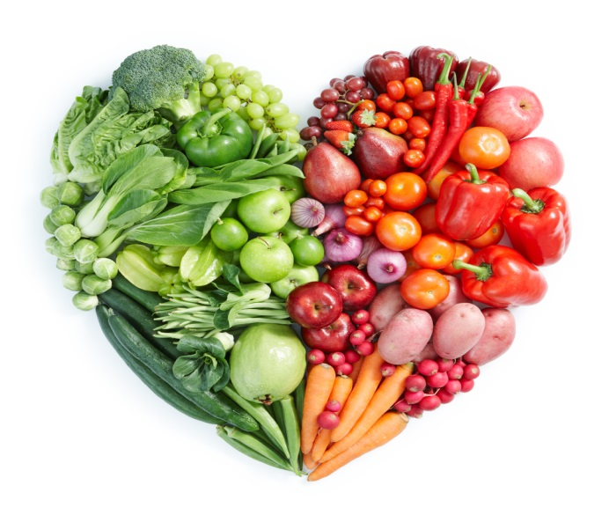

Minestrone Soup

Ingredients
½ onion
Small carrot
Piece celery
¼ green pepper
15ml frozen peas or sweetcorn
2 x 15ml tinned tomatoes
5ml tomato puree
400ml water
1 stock cube
2.5ml mixed herbs
25g pasta shapes

Method
1 Peel onion and carrot, wash pepper and celery
2 Chop onion, slice pepper and celery, grate carrot
3 Add water and stock cube to pot
4 Stir in all the ingredients except the pasta
5 Stir well and bring to boil on high heat
6 Reduce heat and simmer the soup (lid on) for 15mins
7 Add the pasta and cook for a further 15mins
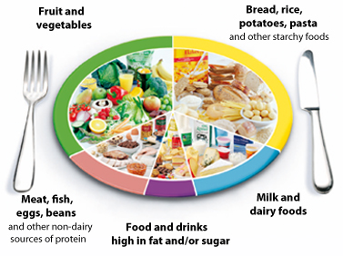
8 Serve piping hot

Quorn Stir Fry

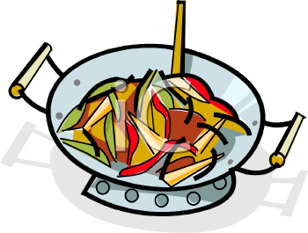
Ingredients
1 fillet of Quorn ½ onion
¼ small green pepper
15ml spoon oil
15ml spoon soy sauce
50g long grain rice

Method
- Half fill pan with boiling water and cook rice for 12-15 minutes. When the rice is cooked, drain and put in your container.
- Prepare vegetables:
Slice the pepper into strips;
Peel and slice the onion;
- Cut the Quorn fillet into thin strips.
- Heat the oil in the wok. Gently fry the Quorn strips until lightly coloured.
- Add the vegetables to the frying pan and stir fry for 3-4 minutes.
- Pour in the soy sauce and cook for a further minute.
- Arrange the ingredients on top of the rice.
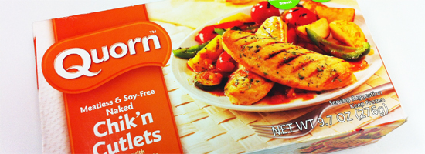

Potato Wedges with Salsa Dip

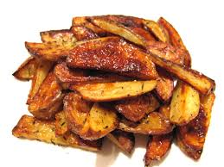
Ingredients
1 medium potato
15ml vegetable oil
15ml mixed herbs or paprika
30ml chopped tomato

¼ red onion
¼ yellow pepper

Method
- Set oven to 200’C or Gas mark 6.
- Collect equipment.
- Collect ingredients.
- Cut potato into wedge shapes.
- Put the oil, wedges and either the mixed herbs or paprika in a large bowl and mix well.
- Lay the wedges on a baking tray and cook for 20 min.
- While the wedges are cooking – finely chop the onion and pepper and mix with the chopped tomatoes.
- Serve the wedges with the salsa on the side.
Pasta with Tomato Sauce

Ingredients
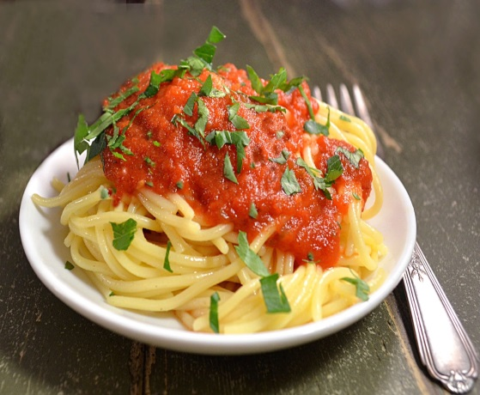
50g pasta shapes
½ a carrot
½ an onion
15ml vegetable oil
200ml chopped tomatoes
½ vegetable stock cube
5ml mixed herbs

Method
- ½ fill a large pan with water and put on a high heat until it comes to the boil.
- Whilst you are waiting peel and chop the carrot in to small pieces.
- Finely chop the onion.
- Add the pasta to the boiling water and cook for 12-15 minutes (until al dente)
- Heat the oil in a small pan for 2 minutes and then add the carrots and onion. Fry for 4-5 minutes.
- Add the chopped tomatoes, stock cube and mixed herbs and simmer for 10 minutes. (Add a little water if the sauce becomes too dry)
- Drain the pasta and serve with the sauce on top.
Apple and Sultana Cakes

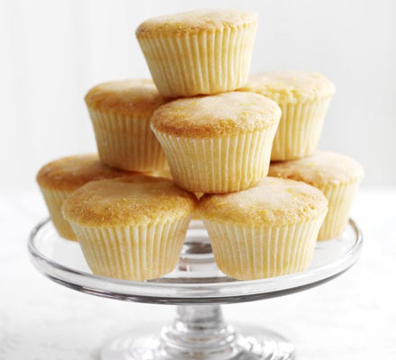
Ingredients
50g soft margarine
50g caster sugar
50g SR flour
1 egg
½ eating apple
25g sultanas

Method
- Set oven to 180’C or Gas mark 5.
- Cream margarine and sugar in large bowl until light and fluffy.
- Beat egg in a cup, sieve flour on to a plate and grate the apple on a chopping board
- Beat in the flour and eggs into the margarine and sugar mixture until smooth. Beat in the apple and sultanas.
- Divide the mixture evenly between 6 paper cases.
- Bake in the oven until they spring back when touched and are golden brown.

Chilli Pockets
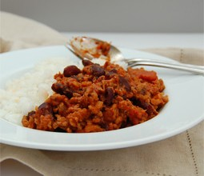
Ingredients:
1 pitta bread
½ onion
50g mince
2.5 ml spoon chilli powder
3 tablespoons chopped tomatoes
50g kidney beans
100mls beef stock

Method:
- Peel and finely chop the onion.
- Measure the stock in the jug; add the chilli powder, tomatoes and kidney beans.
- Place the mince in the stew pan and brown on a low heat; stirring continuously with a wooden spoon.
- Add the chopped onion and cook for 2 minutes.
- Add the contents of the jug to the stew pan, bring to the boil.
- Reduce the heat and simmer for 15 minutes.
- Slit the pitta bread lengthways and place in your container.
- Fill the pitta bread with the mince mixture and serve.

Healthy Apple Crumble

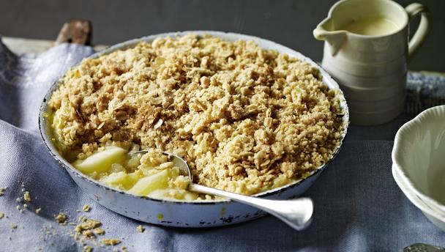
Ingredients:
25g plain flour
25g plain wholemeal flour
50g rolled oats
25g margarine
25g caster sugar
1 apple

Method:
- Set oven to 200’C or Gas mark 6.
- Chop the apple into small pieces and place in your oven-proof dish.
- Measure the flour and margarine into a baking bowl, rub-in the margarine until the mixture looks like breadcrumbs.
- Stir in the caster sugar and oats.
- Sprinkle the crumble mix over the top, do not flatten this.
- Bake until golden brown.
Fish Goujons

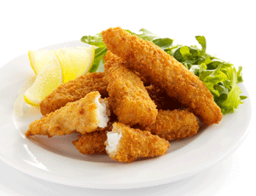
Ingredients – Between 2
2 pieces of white fish
1 egg
25g plain flour
50g golden breadcrumbs

Method
- Set oven to 200’C or Gas mark 6.
- On a red chopping board chop the fish into long dipper shapes.
- Measure the flour and put it on a paper towel.
- Measure the golden breadcrumbs and put them on a separate paper towel.
- Beat the egg in a small bowl.
- Then coat each piece of fish by dipping it in the flour, then the egg and then covering it in the golden breadcrumbs.
- Lay the coated fish goujons on a greased baking tray and bake for approximately 15-20 minutes.
Easter Nests
Ingredients-Between 2
8 Shredded Wheat biscuits
250g milk chocolate
100g mini eggs
Bun cases
Method
- Crush the shredded wheat biscuits into a bowl using your hands.
- Break or chop the chocolate into pieces and melt in a glass bowl over boiling water. Remove from heat when it is melted.
- Pour the shredded wheat on top of the melted chocolate and mix together.
- When mixed and all the shredded wheat is covered with chocolate, spoon the mixture into bun cases and press down in the middle of each to create a place for the eggs.
- Press 2 or 3 mini eggs into each nest.
- Leave to set.

