S2
Food through Time
Perth Grammar School
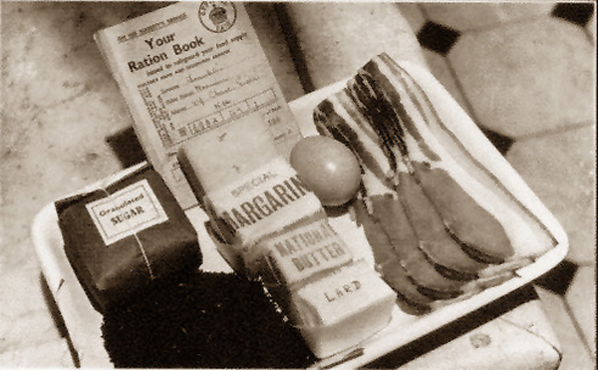

Recipe Book

War Time Honey Biscuits (between 2)
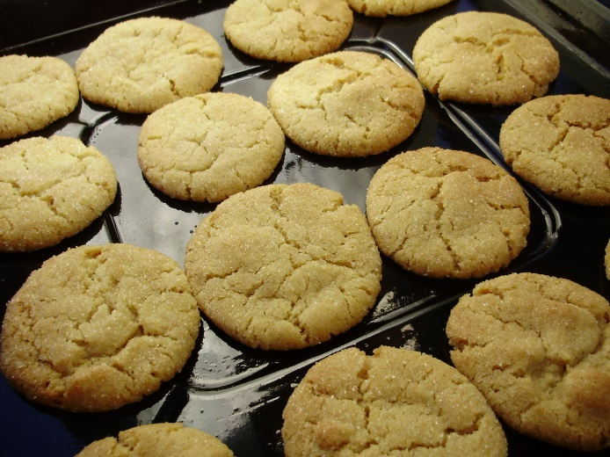
Ingredients:
75g margarine
30g caster sugar
2 tbsp honey
175g self-raising flour
1 tsp cinnamon
Pinch of salt

Method:
- Set oven to 180’C or Gas Mark 5 and line a baking tray with greaseproof paper.
- Cream together the margarine and sugar until the mixture is pale, light and fluffy.
- Mix in the honey and then gradually add in the flour, cinnamon and salt. Keep working the mixture until it comes together into a soft dough.
- Flour a work surface and roll out the dough to approximately the thickness of a £1 coin.
- Use a pastry cutter to cut the dough into rounds.
- Place the rounds onto your baking tray and bake for approximately 10 minutes.
This recipe uses honey as a replacement for some of the sugar because sugar was one of the rationed ingredients during the war.

Nutella Mug Cake
Ingredients:
3 tbsp nutella
1 egg
2 tbsp milk
¼ tsp vanilla essence
4 tbsp SR flour
¼ tsp baking powder
1 tbsp cocoa powder
1 tbsp sugar
Pinch of salt
Method:
- In a microwavable mug, mix together the Nutella, egg, milk and vanilla. Mix with a fork until smooth.
- Add in the flour, baking powder, sugar and salt and mix until combined.
- Microwave for around 50 seconds – 1 minute.
- Check the sponge is cooked by making sure it has a spongy texture. (It might still stay slightly gooey and chocolatey)

The steam created by the microwave cooks this sponge. Because there is no dry heat applied the cake will not go golden or crisp on the outside.

Chicken Curry
Ingredients

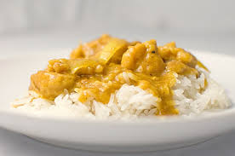
50g rice
½ an onion
10ml oil
5ml curry powder
75g chicken
2 x 15ml sweetcorn
5ml tomato puree
5ml coconut (optional)
½ stock cube
150ml water

Method
- Half fill a pot with water and bring to the boil for rice. Peel and finely chop the onion.
- Cut up the chicken into bite sized pieces.
- Add the rice to the boiling water, cook for 15 mins until soft.
- Heat the oil in the pot and stir fry the onions and chicken until the chicken is white all the way round.
- Add in all remaining ingredients, stir well.
- Bring to boil then turn down the heat and simmer 10 minutes with the lid on. Remove the lid for the last few minutes if your sauce is still very runny.
- Drain the rice through a sieve. Put the rice in your serving dish and pour the curry on top.

Curries originate from Asian countries like India because many of the spices used grow well there.

Spaghetti Carbonara

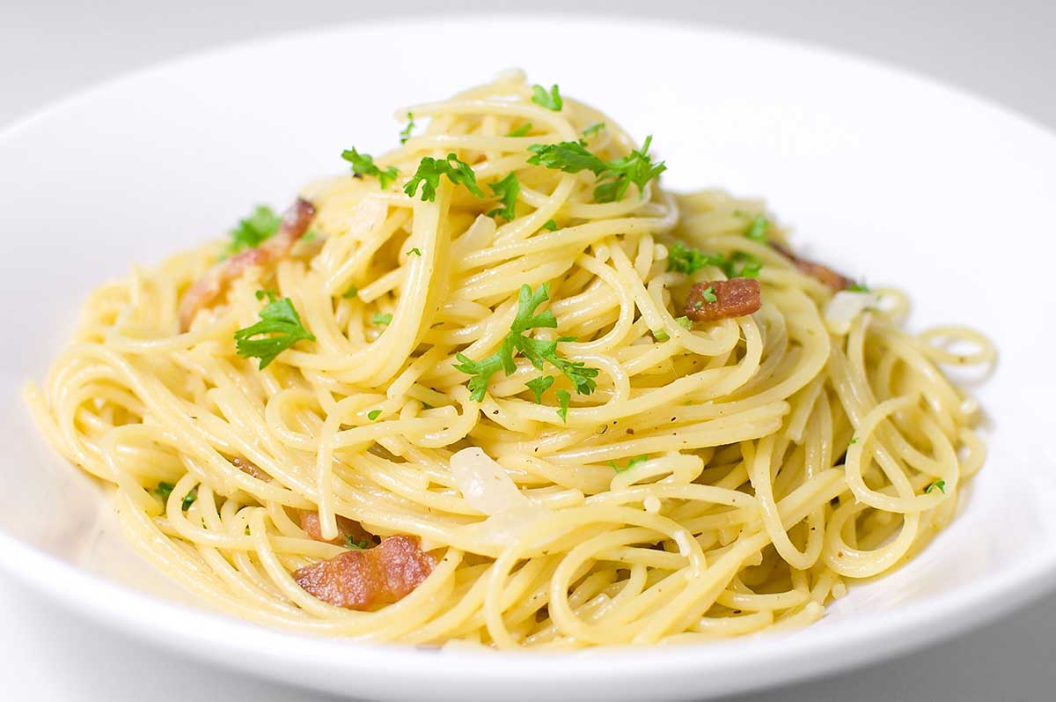
Ingredients
50g spaghetti
½ onion
1 rasher bacon
15g marg
Pinch mixed herbs
10ml hard cheese
2 x 15mls cream
Salt & pepper

Method
- Half fill a pot with water and a little salt and bring to the boil.
- Add spaghetti to water when boiling and cook 12 – 15mins until al dente.
- Peel and finely chop the onion.
- Cut the bacon into small pieces. Grate the cheese.
- Melt the margarine in a small pot and add the bacon & onion and fry gently. Do not allow to brown, stir in the herbs. Remove from heat.
- When the spaghetti is ready strain through a sieve over the sink.
- Add the spaghetti to the bacon mixture, stir in the cream and cheese - mix well.
- Taste and add salt & pepper if necessary. Serve piping hot.
Pasta originates from Italy. It is made from flour and water and sometimes egg. You get lots of different varieties of pasta.

Beefburger and Potato Wedges
Ingredients
75g mince
15ml breadcrumbs
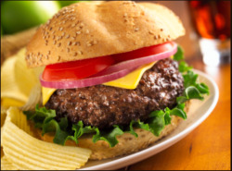
1/2 onion
A little beaten egg to bind
Salt & pepper
1 soft white rolls

½ baking potato
15ml veg oil
5ml paprika or mixed herbs

Method

- Set oven to 200’C
- Chop the potato into wedge shapes
- Coat the wedges in the oil and parika or mixed herbs
- Lay wedges on a baking tray bake for approx. 15 to 20 minutes
- Peel and finely chop the onion.
- In a bowl mix together, using a fork the mince, onion,
breadcrumbs, salt & pepper with a little egg to bind them together.
- Turn the mixture onto a lightly dampened chopping board. Shape
into a burger.
- Preheat the grill on a HIGH heat setting.
- Grill the burger until cooked all the way through – there should be no pink meat in the middle.
Burgers are often thought of as an unhealthy food but homemade burgers made with lean meat have little fat and provide a good source of both protein and carbohydrate.

Summer Stir Fry

Ingredients
½ onion
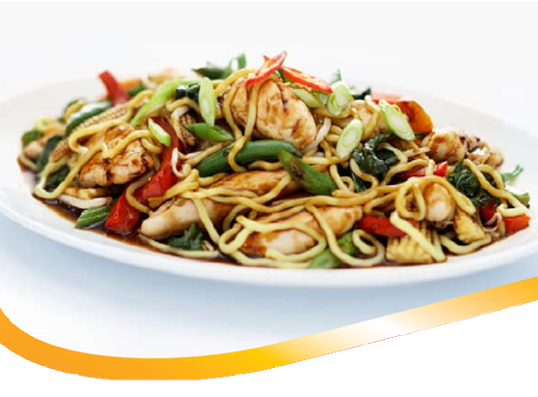
Small carrot
Piece courgette
¼ red pepper
1 mushroom
5ml soy sauce
1.25ml chilli powder
1 x 15ml oil

75g egg noodles

Method
1. Half fill a pot with salted water and heat until boiling.
2. Peel the onion and carrot, wipe the mushroom and then wash courgette and pepper
3. Chop the onion roughly, slice the carrot into rings and cut courgette into thick sticks.
4. Slice mushroom then remove seeds from pepper and cut into strips.
5. Add the noodles to the boiling water and cook until soft (5mins approx).
6. Mix the soy sauce and the chilli powder together in a small bowl.
7. Heat the oil in a wok, add the vegetables and stir fry until the
onions are just beginning to colour – do not overcook or the vegetables
will lose their crispness.
8. Pour in the soy sauce and chilli mixture and continue to cook for 3 – 4 mins.
9. Drain the noodles through a sieve and add to the stir fry mixture.
10. Mix all the ingredients together thoroughly and serve piping hot.
Stir Frying is a good way of using up vegetables which may be left over. It is also a healthy method of cooking as only a little oil is used.

Speedy Paella

Ingredients
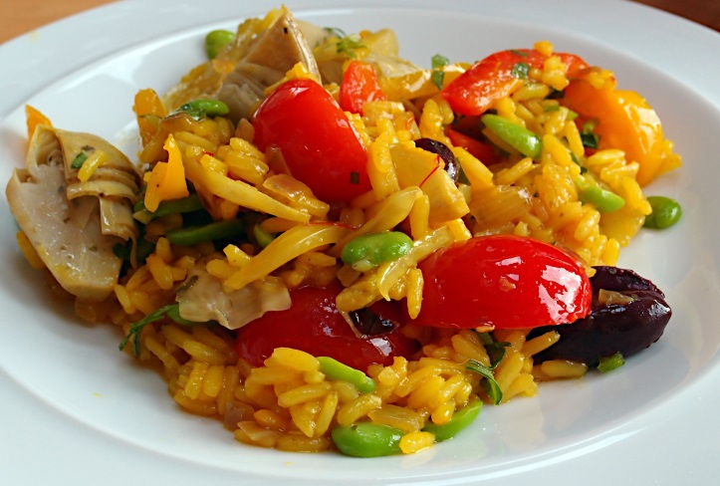
½ onion
1 clove garlic
1 tomato
25g frozen peas
¼ red pepper
75g long grain rice
½ veg stock cube
250ml water

Method
1. Peel and chop the onion then peel and crush the garlic.
2. Chop the tomato and pepper into small pieces
3. Heat the oil in a pan and add the onion and garlic- stir fry until soft (3/4 mins).
4. Add the tomatoes, peas, peppers and rice, stir to coat with oil.
6. Pour in the water and crumble in the stock cube, stir well and bring to boil
7. Turn down to a low heat and allow the mixture to cook gently until most of the liquid has been absorbed and the rice is soft.
8. Taste before serving and add salt and pepper if necessary.
In this recipe the rice cooks by absorbing all of the hot liquid. This is different from boiling rice where lots of liquid is used and the rice is drained at the end.

