S3 Home Economics
Community Link Recipe Book

Basic Sponge Cakes
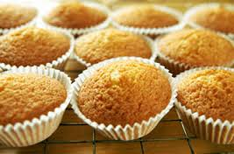
Ingredients
50g SR flour
50g margarine
50g caster sugar
1 egg

Method
1. Pre-heat the oven to 190’C or Gas No 5.
2. Put 6 paper cases into bun tin.
3. Beat margarine in mixing bowl using a wooden spoon to soften.
4. Sieve sugar into mixing bowl and cream with margarine until light and fluffy.
5. Add the egg a little bit at a time and beat well after each addition.
6. Gradually fold in the flour using a metal spoon – do not beat
7. Divide the mixture equally between the paper cases. Bake for 15 -20 minutes until they are well risen and golden brown. Put on a cooling tray to cool.

Viennese Whirls
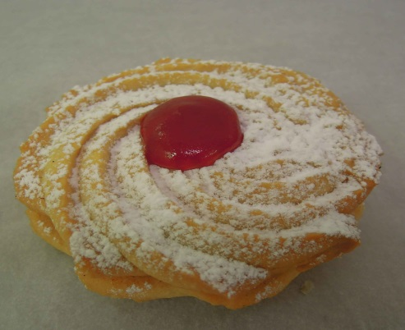
Ingredients
75g Plain flour
75g margarine
25g icing sugar
few drops vanilla essence
2 cherries

Method
1. Heat the oven to 170’C/ Gas Mark No.3 and grease a baking tray.
2. Sieve the flour onto a plate.
3. Sieve the icing sugar into the mixing bowl and add the margarine.
4. Cream the sugar and margarine together using a wooden spoon.
5. Beat in the vanilla essence then mix in the flour a little at a
time with your wooden spoon working the mixture well before each addition.
6. Spoon the mixture into a piping bag fitted with a large star nozzle.
7. Pipe 8 whirls onto a baking tray leaving an adequate space between them.
8. Cut each cherry into 4 pieces. Place a piece of cherry in the middle of each whirl.
9. Bake until the biscuits are a very light golden brown approx 15 – 20mins
10. Remove the biscuits from the oven and allow to cool for around 5mins. Then carefully lift off the baking tray with a fish slice onto a wire cooling rack and leave until cool.

Savoury Picnic Scones
Ingredients
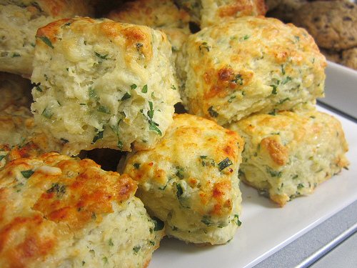
100g SR flour
50g Wholemeal flour
Pinch baking powder
Pinch of mixed herbs
25g marg
70ml milk (approx)
50g cheese

Method
1. Heat oven to 200C or Gas No 7 and grease a baking tray.
2. Grate the cheese and leave in a small bowl.
4. Sieve the flours and baking powder into a mixing bowl and add the margarine.
5. Cut the margarine into small pieces and rub in till the resembles fine breadcrumbs.
6. Add the cheese and herbs and mix well.
7. Using a knife add enough milk to make a soft dough.
8. Turn onto a lightly floured surface and knead.
9. Roll out gently and use pastry cutters to cut out approx. 6 scones.
10. Brush with a little leftover milk and sprinkle with the remaining cheese.
11. Bake until golden brown (about 15 -20 mins)

Banana Buns
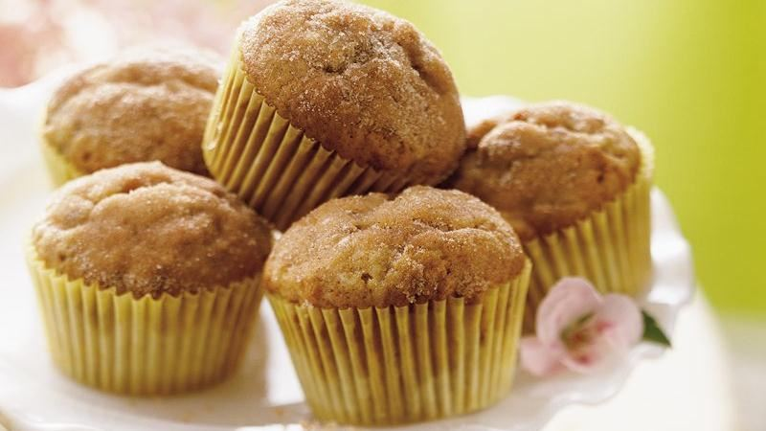
Ingredients
100g SR flour
30g margarine
60g soft brown sugar
½ banana
50ml milk
2.5ml vanilla essence
1 egg

Method
- Set the oven to 190’C or Gas No 6.
- Mix the vanilla essence with the milk and whisk the egg into the milk mixture in a measuring jug.
- Chop the banana into small pieces.
- Cream the margarine and the soft brown sugar together in a large bowl.
- Add half the egg and milk mixture with half the flour to the creamed mixture and beat.
- Add the remaining egg/milk and flour and mix thoroughly.
- Add the chopped banana and mix.
- Divide into 6 paper cases and bake for 15-20 minutes.

Sausage Plait
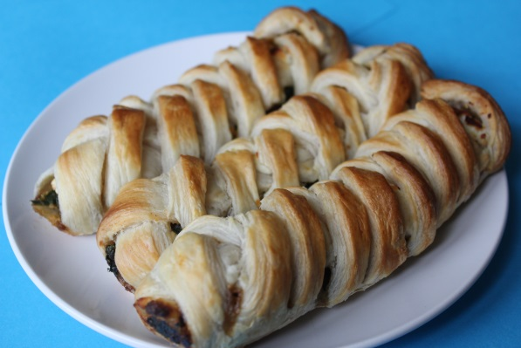
Ingredients
100g shortcrust pastry
75g sausage meat
1.25ml mixed herbs
¼ egg
Method
- Set oven to 200’C or Gas Mark 6.
- Lightly dust the table with flour and roll out pastry to a rectangle about the thickness of a 50p coin.
- Mix together in a bowl the sausage meat and herbs.
- Lightly mark the dough in three lengthwise. Pile the filling down the centre.
- Make 8 slanting cuts to within 2cm of the filling down each side.
- Damp each side with water and fold in the ends.
- Fold the strips over the filling alternatively, making a neat plait.
- Brush with the beaten egg and bake for 15-20 minutes, or until golden brown.
- Cut into bite size pieces and serve.

Pitta Pizza’s
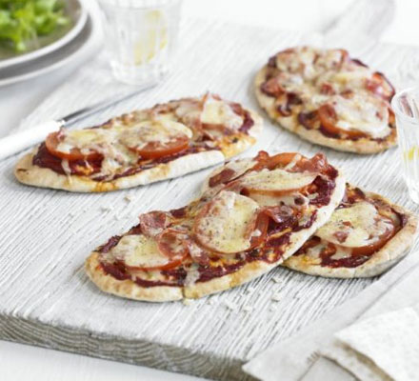
Ingredients
2 pitta breads
2 tbs tomato puree
2 tsp mixed herbs
1 tomato (sliced)
50g grated cheese
Method
- Set the grill to a high heat.
- Spread each pitta bread with 1 tbsp tomato puree.
- Sprinkle over the mixed herbs, then lay on the tomato slices.
- Sprinkle over the cheese and grill until the cheese is golden and bubbling.
- Slice the pitta pizza’s into finger food size pieces.

